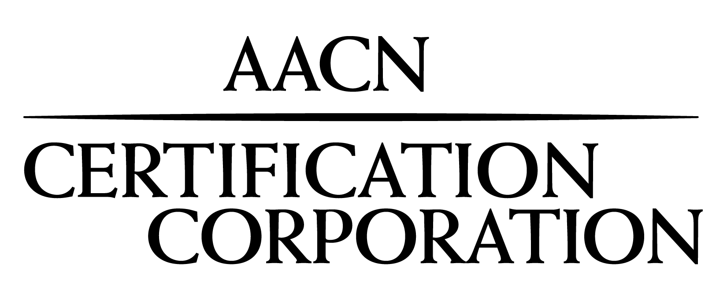
Certification Organization for the American Association of Critical-Care Nurses

Click here to enter a date.

Dear Administrator or VP of Nursing:

It is my distinct pleasure to inform you that your employee, Click to enter your full name., has successfully renewed their CMC® (cardiac medicine) certification. Achievement and maintenance of a subspecialty credential such as CMC offers additional validation of a nurse’s advanced clinical knowledge and tangibly demonstrates a commitment to patients and families, employers and colleagues. You can be very proud to know that a nursing professional of this caliber represents your facility.

The importance of clinical certification to the health and well-being of patients in the U.S. has been well documented. Research studies have specifically linked certification to higher levels of job satisfaction, clinical knowledge, experience and skill. These studies have found that certified nurses were particularly motivated to maintain clinical excellence even in rapidly changing acute and critical care environments. In addition, maintaining a subspecialty certification, where current specialty certification is required, is a testament to a nurse’s resolve and dedication to the honored profession of nursing.

On behalf of AACN Certification Corporation, I wish to express my sincere appreciation for the investment your facility has made in its nurses, which will ultimately benefit the patients you serve. If you would like additional information about the certification programs offered by AACN, please contact us at 800-899-2226 or visit www.aacn.org > Certification.

Thank you for your continued support and commitment to nursing certification.

Sincerely,


Dana Woods, MBA
Chief Executive Officer

