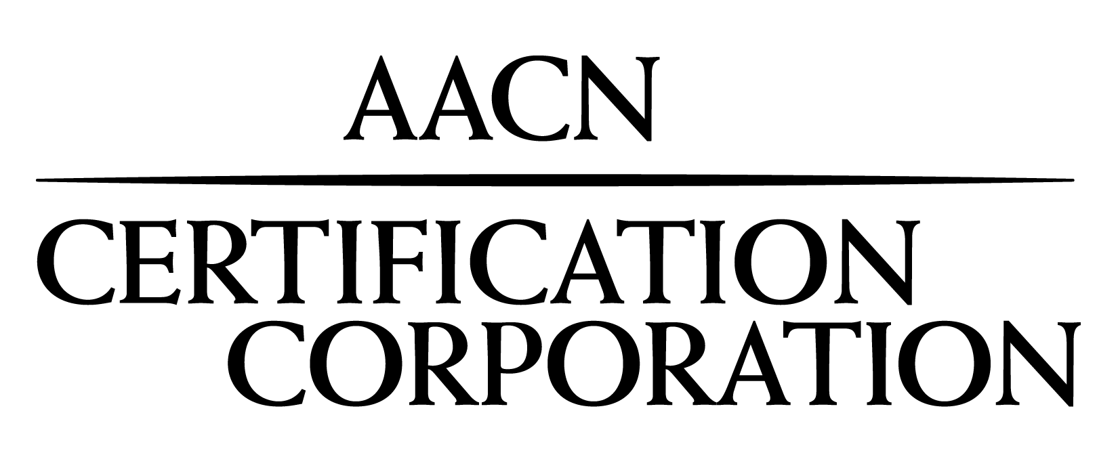
Certification Organization for the American Association of Critical-Care Nurses

Date: Click here to enter a date.

Dear Administrator or VP of Nursing:

It is my distinct pleasure to inform you that your employee, Click to enter your full name., has successfully completed the CSC® (cardiac surgery) certification exam. Earning a subspecialty credential such as CSC offers additional validation of a nurse’s advanced knowledge and serves to demonstrate a commitment to patients and families, employers and colleagues. You can be very proud that a nursing professional of this caliber represents your facility.

The importance of clinical certification to the health and well-being of patients in the United States has been well documented. Research studies have linked certification to higher levels of job satisfaction, clinical knowledge, experience and skill. These studies have also found that certified nurses are particularly motivated to maintain clinical excellence even in rapidly changing acute and critical care environments. In addition, achieving a subspecialty certification, where current specialty certification is required, is a testament to a nurse’s resolve and dedication to the honored profession of nursing.

On behalf of AACN Certification Corporation, I wish to express my sincere appreciation for the investment your facility has made in its nurses, which will ultimately benefit the patients you serve. If you would like additional information about the certification programs offered by AACN, please contact us at 800-899-2226 or visit www.aacn.org > Certification.

Thank you for your continued support and commitment to nursing certification.

Sincerely,


Dana Woods, MBA
Chief Executive Officer

